

# LAB – FILE

**Graphics and Animation Tools - Lab**

**CSGG 4101**

Name – Rishank Gupta

Roll No. – R100217062

Sap id – 500062486

Course – B. Tech CSE-OSS

Batch – 2

*Under the guidance of…*

Dr.Durgansh Sharma

Associate professor

Department of Cybernetics

School of computer Science (Socs)

INDEX

|  |  |  |  |  |
| --- | --- | --- | --- | --- |
| **S. No.** | **Experiment** | **Date of**  **Experiment** | **Date of**  **Submission** | **Remark** |
| 1. | Installation of GIMP AND BLENDER. | 14-Aug-2020 | 10-Sep-2020 |  |
| 2. | A) Draw with pencil and edit with GIMP.  B) Design of Logo using GIMP. | 20-Aug-2020 | 10-Sep-2020 |  |
| 3. | Design of Google Logo using GIMP. | 27-Aug-2020 | 10-Sep-2020 |  |
| 4. | Design your own animation using GIMP. | 03-Sep-2020 | 10-Sep-2020 |  |
| 5. | Design of 3D Text using Blender. |  |  |  |
| 6. | Design of 3D Hut using Blender. |  |  |  |
| 7. | Design of 3D Rocket using Blender. |  |  |  |
| 8. | Design of 3D Car using Blender. |  |  |  |
| 9. | Design of 3D Mountain Landscape using Blender. |  |  |  |
| 10. | Design of 3D UPES Landscape using Blender. |  |  |  |

**Graphics and Animation Tools - Lab Experiments**

**Experiment- 1**

**Aim: - Installation of GIMP AND BLENDER.**

**GIMP installation Steps**

**Step-1: Download the GIMP installer.** To install GIMP on Windows, visit <https://www.gimp.org/downloads/>, and select the Microsoft Windows Platform. Consider the below image:

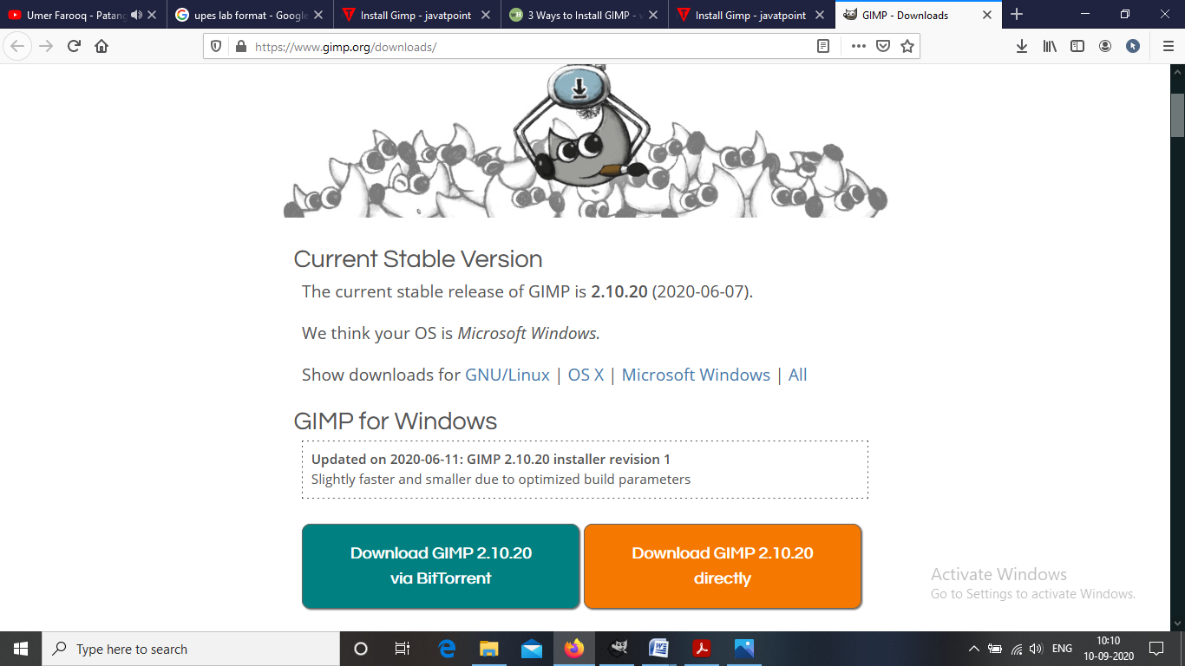

There are two download options available. Either we can download it via torrent or directly.

**Step-2: Run the GIMP installer.** It will be saved in your downloads section.

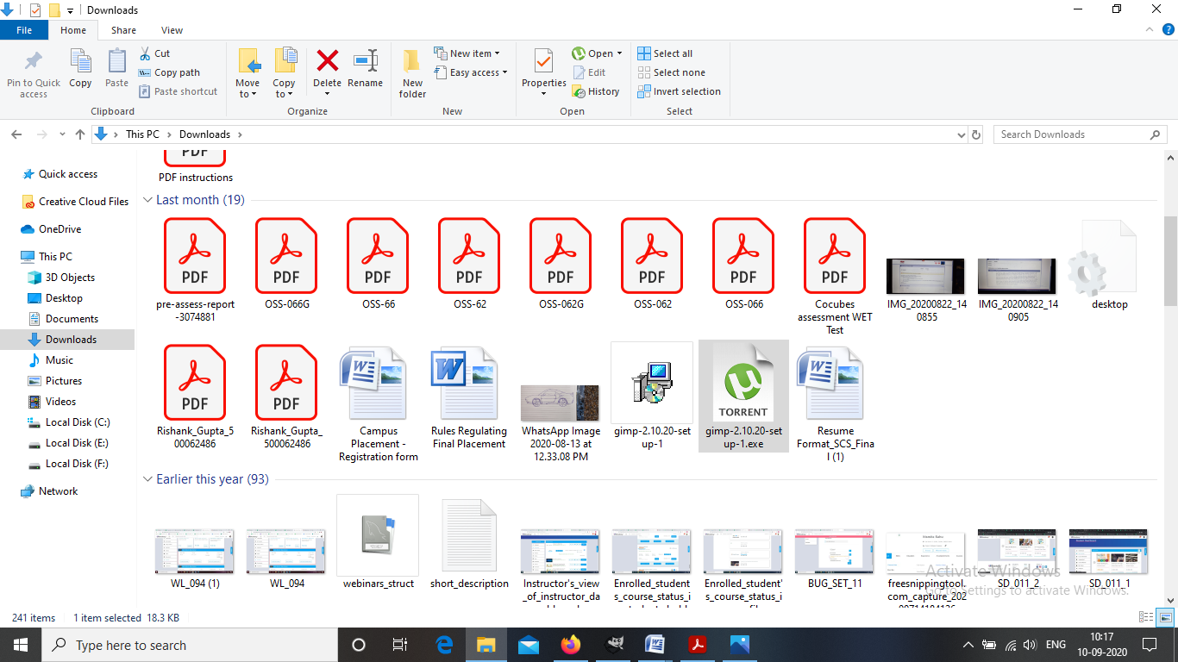

**Step-3: Follow the required prompt.** I leave them defaults and click on install.

**Step-4: Finish the Installation.** After selecting the file formats, it will take few minutes to install and then click on finish.

**Step-5: Start using GIMP.** Once GIMP is installed, you can start using it.

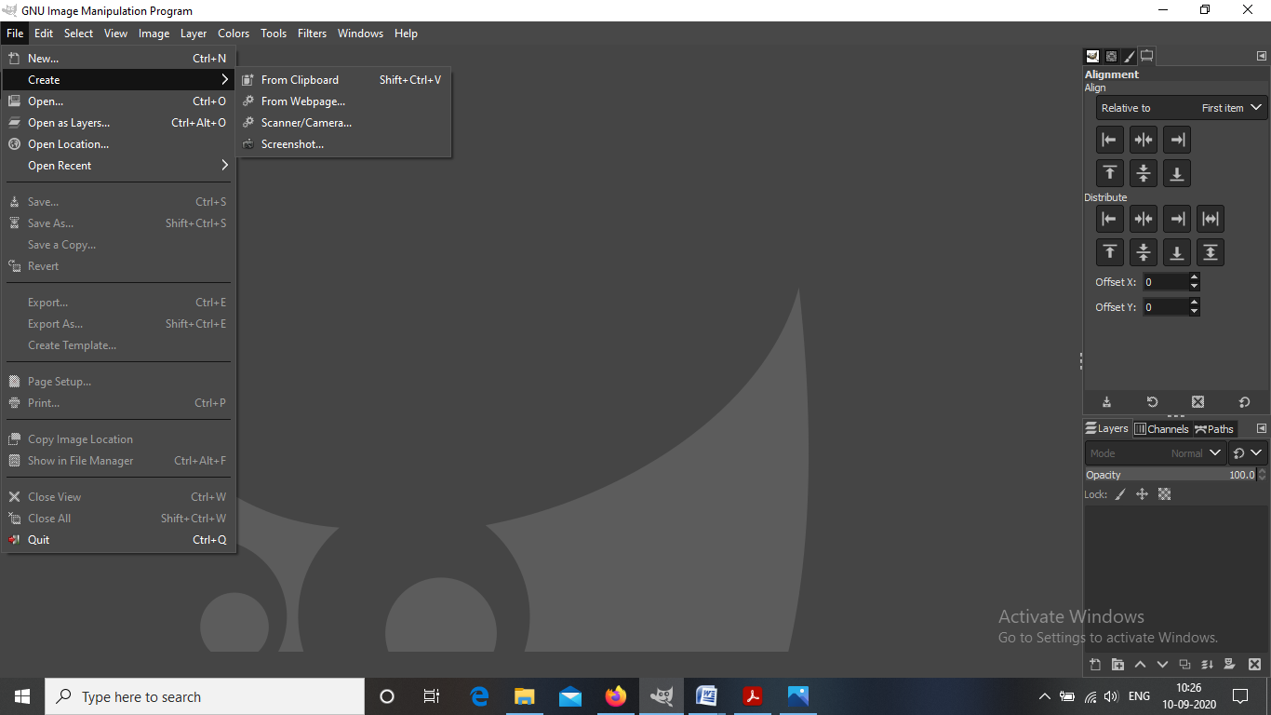

**BLENDER installation Steps**

**Step-1: Navigate to the Blender website.** [www.blender.org/](http://www.blender.org/)

**Step-2:** You can directly download the blender from here.

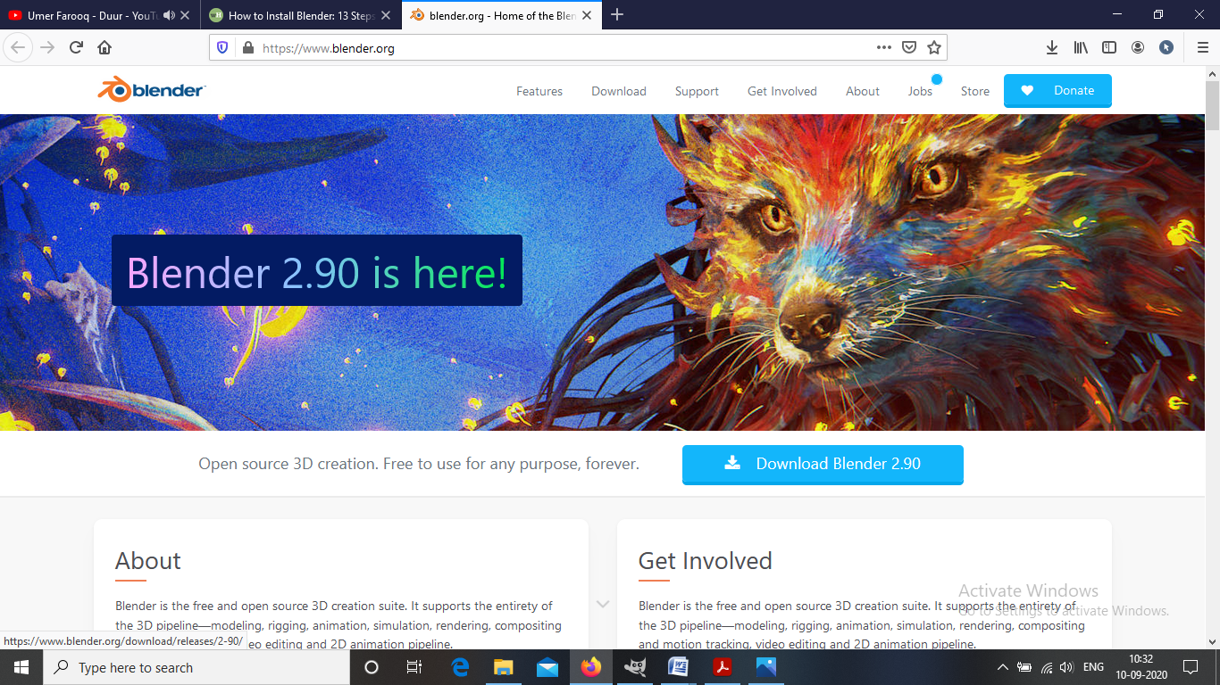

**Step-3: Run the installer.** It will usually be located in your download folder.

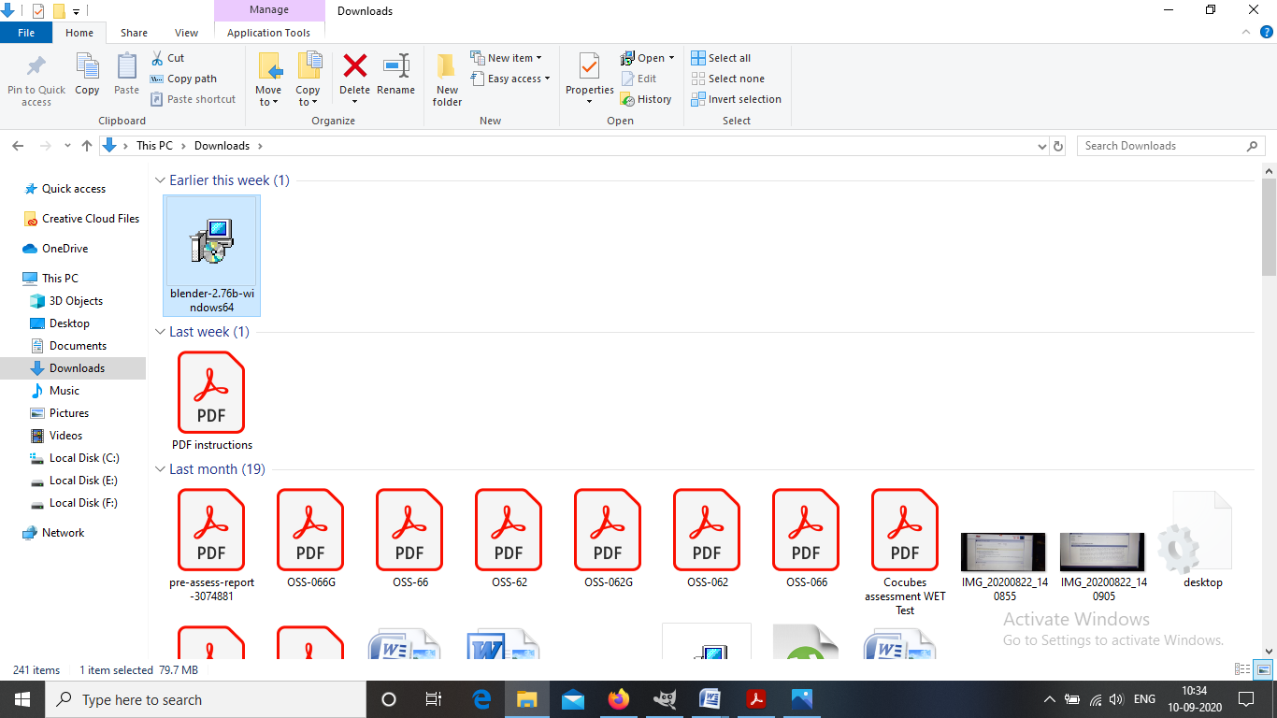

**Step-4: Start the installation process.** Click Next

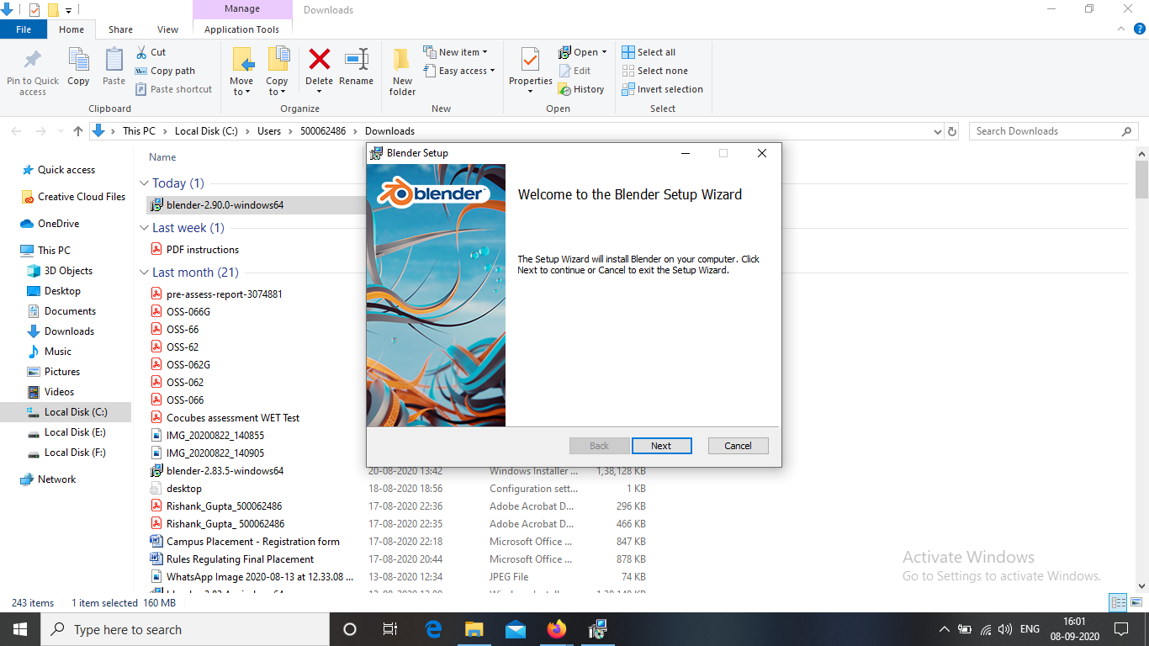

**Step-5: Agree to the Terms and Conditions.** When prompted, click I Agree in the installation wizard.

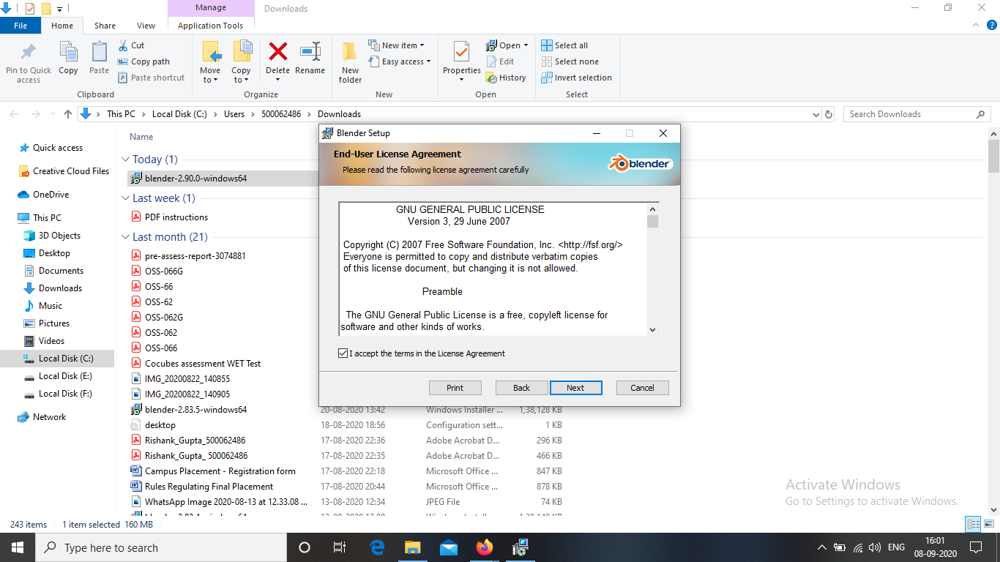

**Step-6: Choose a destination folder.** The default location is the Program Files folder of Drive C:\ in your computer. You may change the location of the application by clicking Browse.... Then click Install.

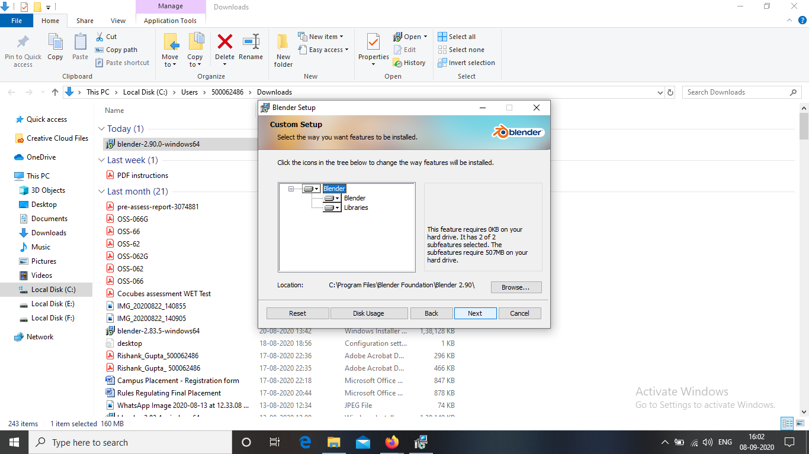

**Step-7: Finish the installation.** Click Finish when the installation is completed. Blender is now installed in your computer. You can start exploring the application when it starts automatically.

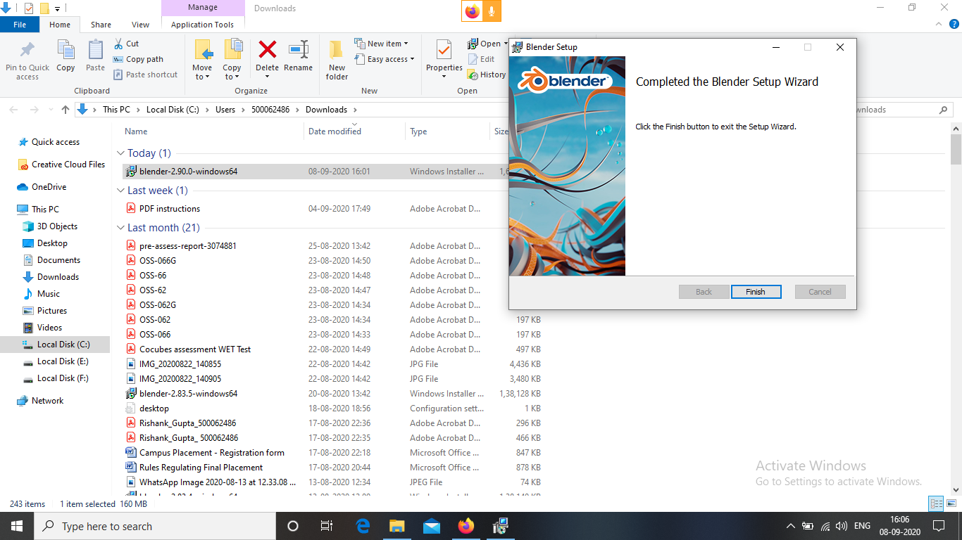

**Step-8: Now start using the BLENDER.**

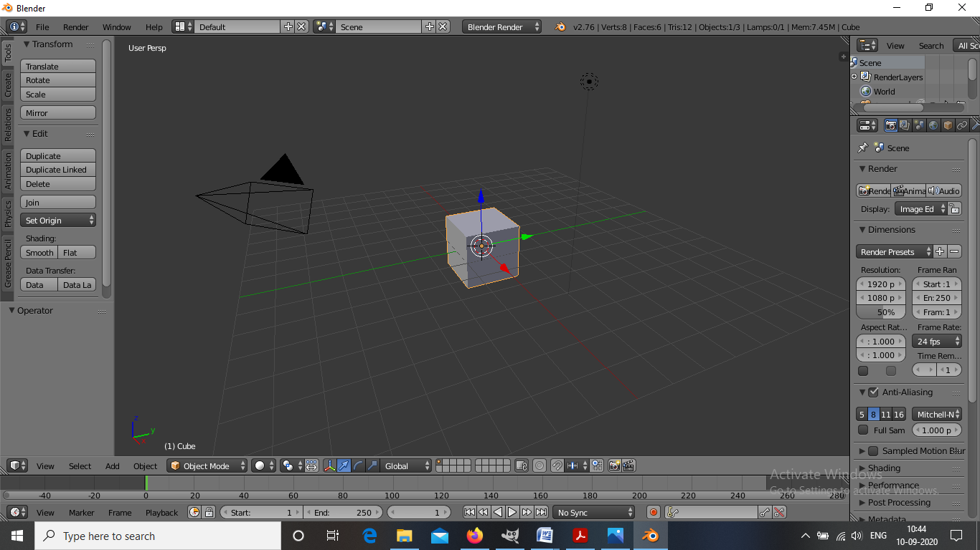

**Experiment- 2(a)**

**Aim: - Drawing something on paper with a pencil and then design it will GIMP.**

**Steps taken for designing the sketch**

**Step1:** Draw something on paper with a pencil.

**Step2:** Open GIMP and click on **New > Open** as layer and open the image as above.

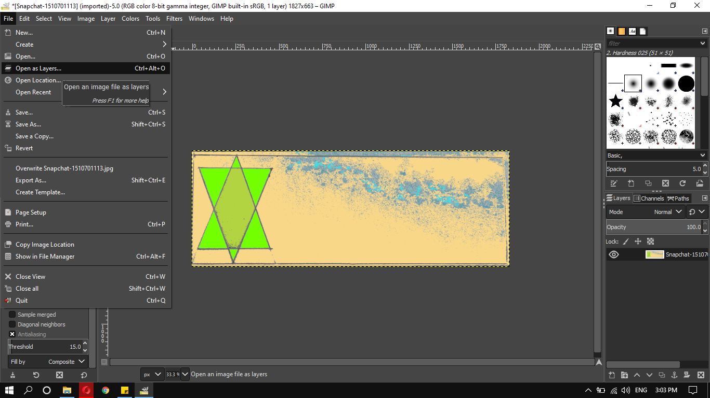

**Step3:** The image can now be edited using GIMP.

**Step4:** Export the image as **.PNG or .JPG**.

**Drawing with Pen:**

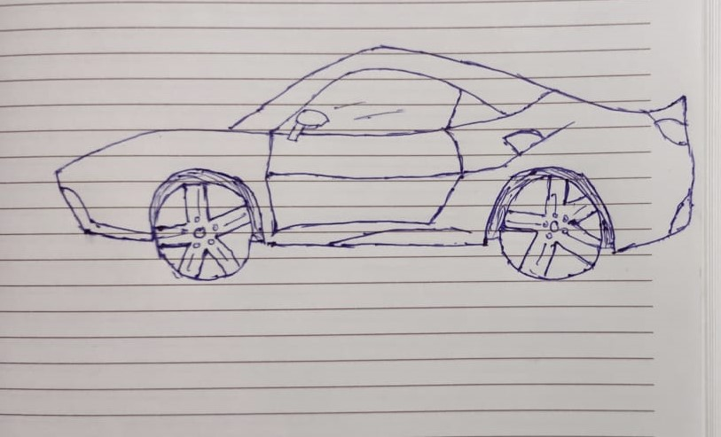

**Experiment- 2(b)**

**Aim: - Design of Logo using GIMP.**

**Steps taken for designing the logo**

**Step-1:** The very first thing what I did I just go to **file > New** and then I size the document **1280/1280 (w/h)** and in advanced option I make sure that fill with option is transparency and click OK.

**Step-2:** Now I got my new document and now I go **to Image> Guides> New guides by percent** and I select Horizontal direction and select position **50%** and click OK and did the same thing again select Vertical direction and select position **50%** and click OK.

**Step-3:** Now I go to **Ellipse** tool and draw a circle from the intersection point of vertical and horizontal guides. I make sure my default colour and background colour is white and black respectively.

**Step-4:** Now I go to **Edit> Fill with BG colour** and check the circle is filled black, go to **select>none**. Again I draw a circle smaller then before and press Delete on Keyboard to get rid of that filled area. Bring down the opacity lower. Create a new layer over that BG layer.

**Step-5:** Now I go to **Rectangular** tool and draw a rectangle from the centre slightly smaller than circle but big enough to over the edges of circle. Now I go to **Edit> Fill with BG colour** and check the rectangle is filled black, go to **select>none**. Again I draw a rectangle smaller then before and press Delete on Keyboard to get rid of that filled area. Bring down the opacity lower.

**Step-6:** Now I click on **Rotate** and rotate the rectangle at 50 and select enter. Now I create a new layer and select **Alpha to selection** then **edit> grow** at 15 px and click OK. Then go to Last layer and Fill it with BG colour and select none.

**Step-7:** Go to **colour** select red and colour it and select erase to cut that overlapping area of circle and rectangle. I leave one side and erase other side, now just select the present layer click to **alpha to selection** and then delete that layer and go back to original layer and press delete on keyboard. So the area will be deleted and **select>none**.

**Step-8:** Select the background layer and go to alpha to selection and **edit> Grow** at 15 px and click OK. Create new layer and **Fill it with BG colour** and select none.

**Step-9:** Go to colour select red and colour it and select erase to cut that overlapping area of circle. Now I just select the present layer click to alpha to selection and then delete that layer and bring the opacity **100**. Now I have the border for the **LOGO**.

**Step-10:** Select the top layer and click on **TEXT** tool and write LAB in any FONT then I simply go to MOVE tool and bring the text to centre and the I go to **alignment** tool and check vertical-horizontal alignment.

**Step-11:** click on TEXT tool and write Graphic in any FONT then I simply go to **MOVE** tool and bring the text to upper to the **LAB** and check alignment.

**Step-12:** Now I duplicate the last layer and click on **TEXT** tool and write Animation in any FONT then I simply go to **MOVE** tool and bring the text to lower to the **LAB** and check alignment.

**Step-13: LOGO** is completed and I export it as PNG file.

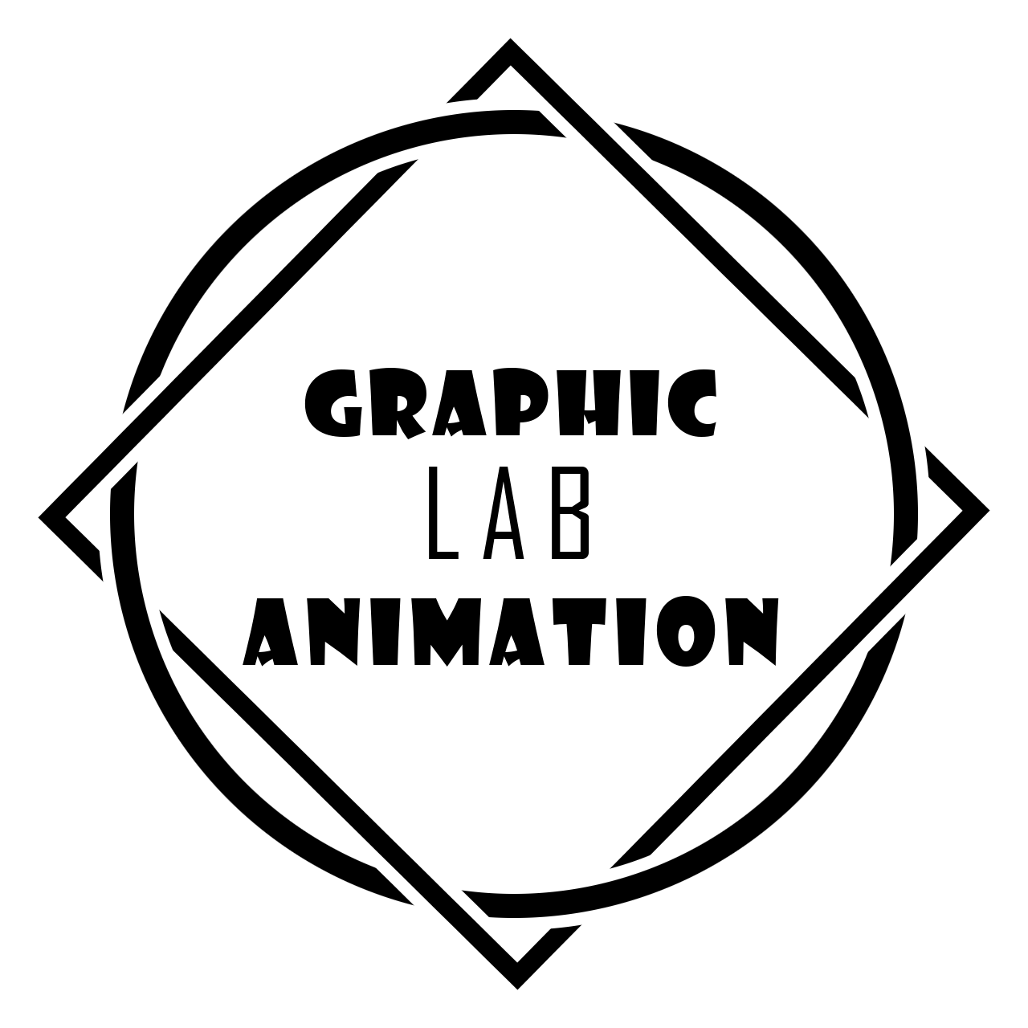

**Experiment- 3**

**Aim: - Design of Google Logo using GIMP.**

**Steps taken for designing Google logo**

**Step 1:** Open GIMP, go to **File> New file>** & choose 1080x1080 size screen keeping the background white.

**Step 2:** Go to **Image> Guides> Guides by %>** and choose the 50% horizontal guide and 50% vertical guide subsequently.

**Step 3:** Now choose the **Ellipse** tool from toolbar, and start drawing a circle at the quadrant of your choice. Use Ctrl+Shift to position it at the center.

**Step 4:** Go to **select> none**.

**Step 5:** Go to **path> Make the selection visible> Now**, add it to the text.

**Step 6:** Right-click on the text layer, choose text **along path> go to path** and add a new layer to it.

**Step 7:** Go to Path, **Text1> Transparent, Fill the path> solid color> delete** text1 path.

**Step 8:** Now for Text2, click on **Toolbar> Flip tool> Transform row> Direction** Flipping.

**Step 9:** Now go to the **Text layer> right-click** on **Text-2> Text along path>**Adjust the position of 2nd text by rotate tool under the toolbar box.

**Step 10:** Add new layer from Text2, select **that Layer>Go to the path>Right** click on it, select text along path. Select Fill with solid color option.

**Step 11:** Go to File and open the Google logo as layer and place it in the center and make other layers invisible using the eye sign on the right of the layers/selections.

**Step 12:** Save the output and export it at another location using **.XCF** extension.



**Experiment- 4**

**Aim: - Design your own animation using GIMP.**

**Steps taken for Animation Design**

**Step1:** In the process of a creation of simple animation in GIMP, first we need to procure images which can be made into GIF or create them using Paint.

**Step2:** Open GIMP, and go to **File> Open as Layers> and** open all the pictures as layers, ordered in chronological order.

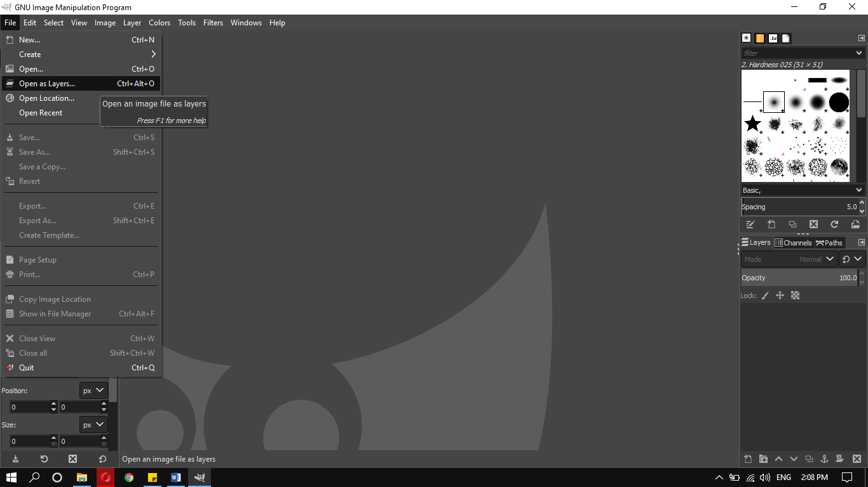

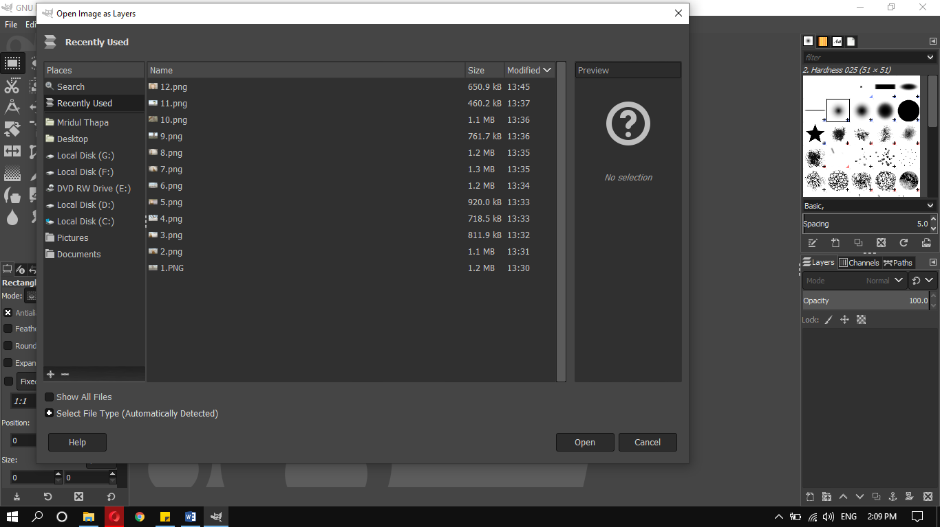

**Step3:** After opening all the pictures as layers, go to **EXPORT AS** and save the picture in any folder of your choice using the extension **.GIF**.

The Export Image as GIF dialog box pops up, export it as animation. Set the delay between frames of your choice in milliseconds, it means the time delay between the pictures.

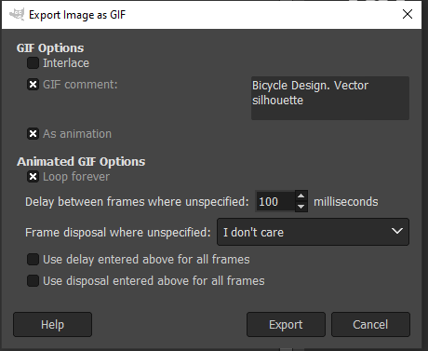

**Step4:** The saved file with the extension of .GIF is now saved and the pictures now work with the delay we set on the export dialog box.

